Name: Md Tamim Ikbal

ID:23066608

GitHub Link:

**Analysis report on Daily Activity**

Introduction: This report compares the daily activity data collected from Fitbit fitness tracker data. The dataset contains six columns ,940 entries, and 30 different users. From the six columns, three key metrics total steps, calories burned and total distance were taken to analysis and visualize. The purpose of this analysis is to understand pattern in daily physical activity of users.

Description: Three main visualizations were selected bar chart, line plot and heatmap.

1. Bar-chart:

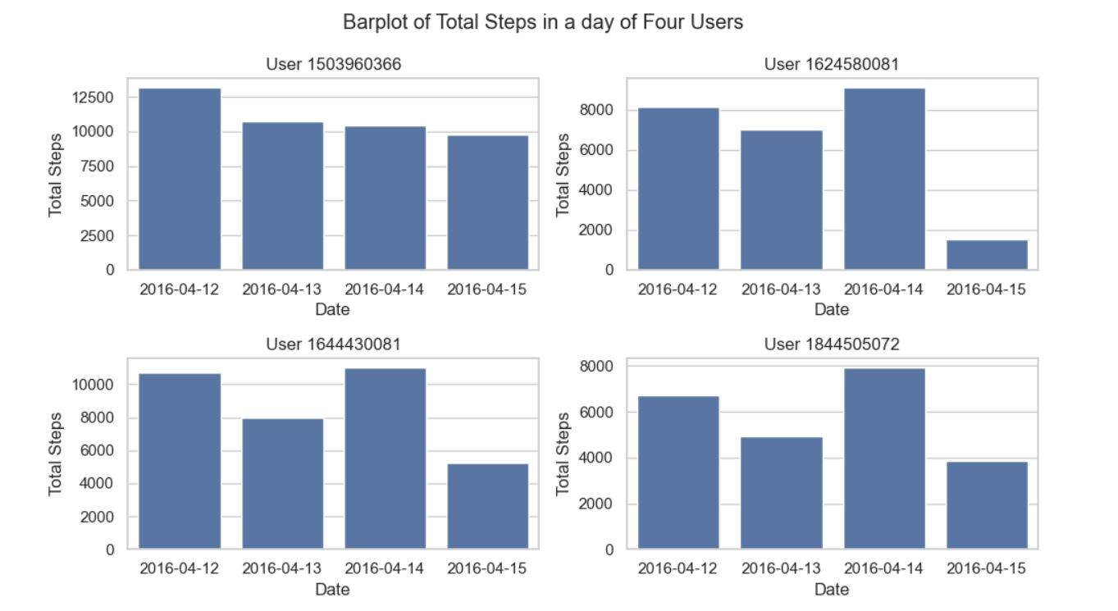Bar chart is used to observe the distribution of total steps of a user in a single day. Mainly this bar plot analysis and shows the four unique user’s total foot step in a single day for four different days. Also, we can observe the maximum and minimum total step of a user and can compare among the user.

Fig.1.Barplot of Total Footstep

1. Line-plot

Line plots used to denote Calories burned of a user over time. The line plots show two user’s calories burned from 12th April to 12th May. We can observe and analysis the maximum, minimum, average calories burned of each user, also we can compare between them.

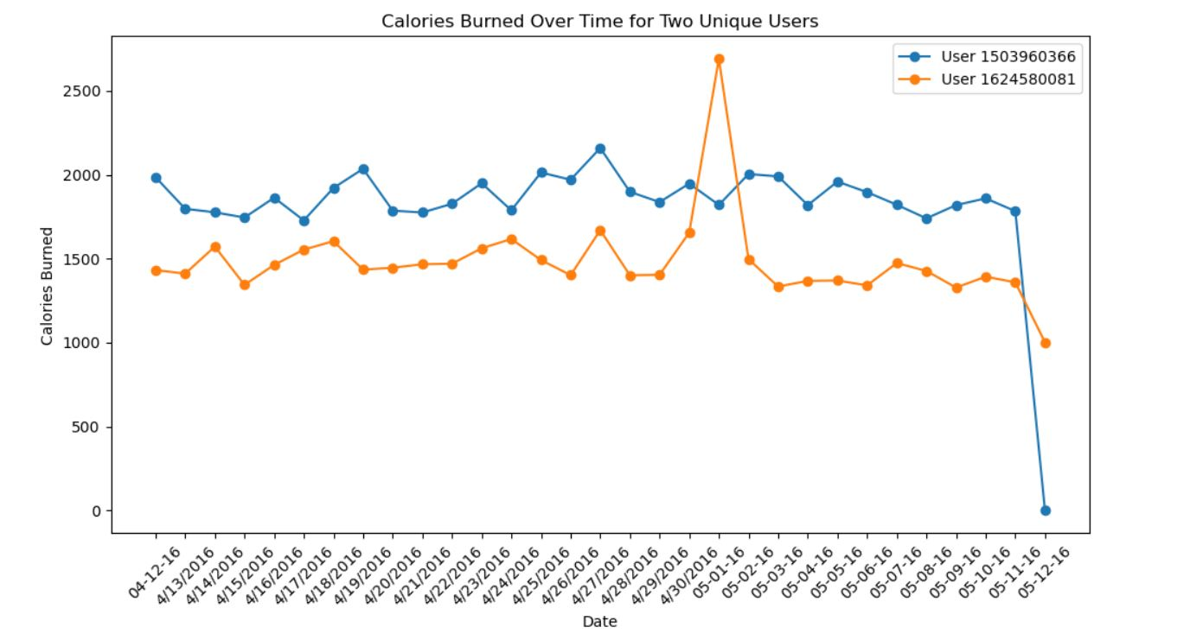Fig.2. Line plot of two user’s calories burned over time

1. Heat-map

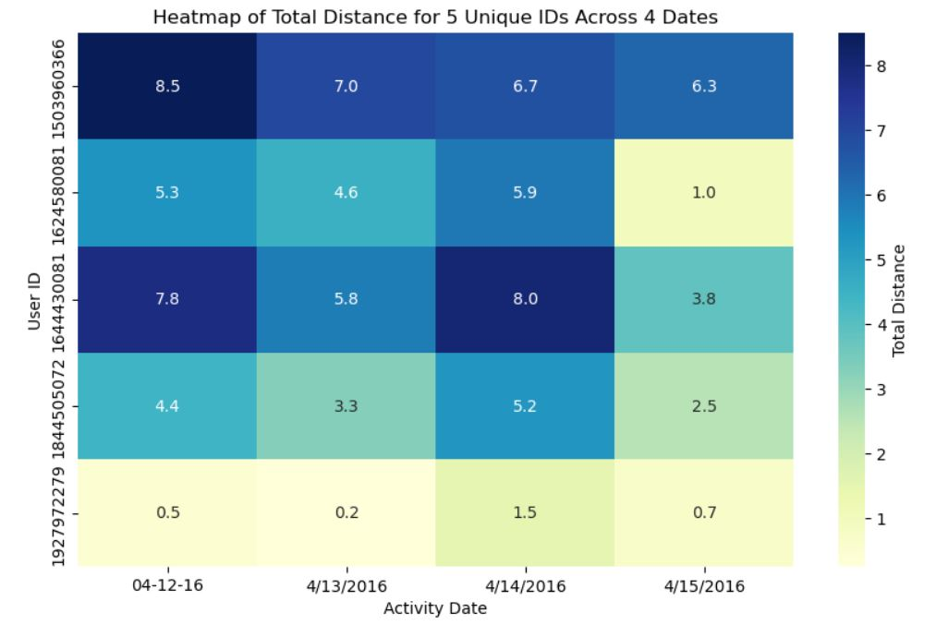This Heatmap to visualize the correlation among five unique user’s total distance. we can see in different date total distance of four user. It shows the difference of total distance by changing the color for each day.

Fig.3. Heatmap of Total distance for five users.

Conclusion: This analysis and visualization by using bar-chart ,line-plot and heat-map of daily activity dataset provides the pattern of physical activity of daily to day life of every user.